DETAILED USAGE REPORT
We had no prior experience cooking with an air fryer. we decided to test the fryer by frying a wide range of meat and vegetables including pork steak, chicken wings, fish fingers; which are preprocessed food and prepacked French fries. 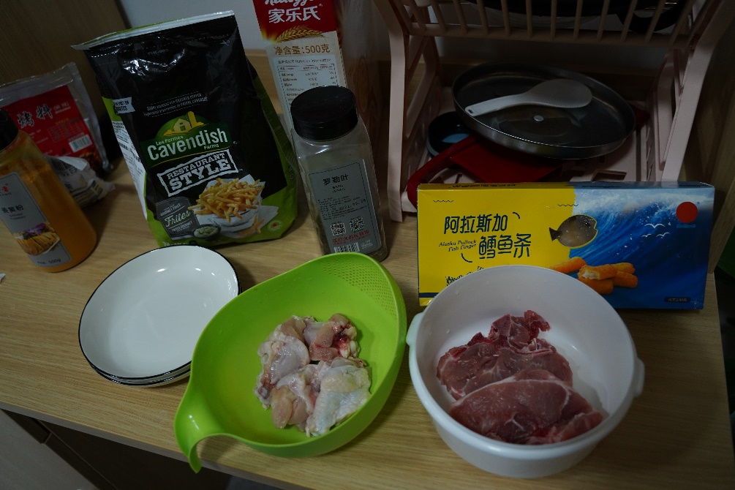
Before use, we cleaned the air fryer following the instructions of the Biyi site to rinse the inner baskets with a sponge some warm water and some dishwasher
Some online sources recommended coating the meats in about a teaspoon of oil while the Biyi website recommended frying with absolutely no oil, so we decided to try both methods of frying for each meat dish. For the pork the meat was slight marinated separated into two portion one of which had a teaspoon of oil and the other had no oil at all.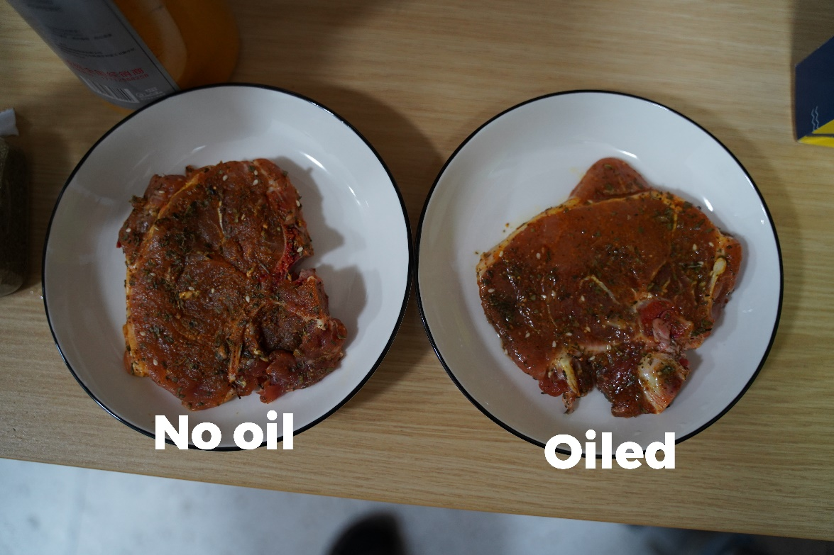
We followed the recommended heat and time recommended on the air fryer which was 180 degrees for 12-18 minutes. we ended up frying the meat at 180 degree Celsius for a total of 30 minutes (the steak was flipped over at a 15-minute interval.) this was because the recommended time was not long enough to fully cook the pork steak (since we prefer it well done).
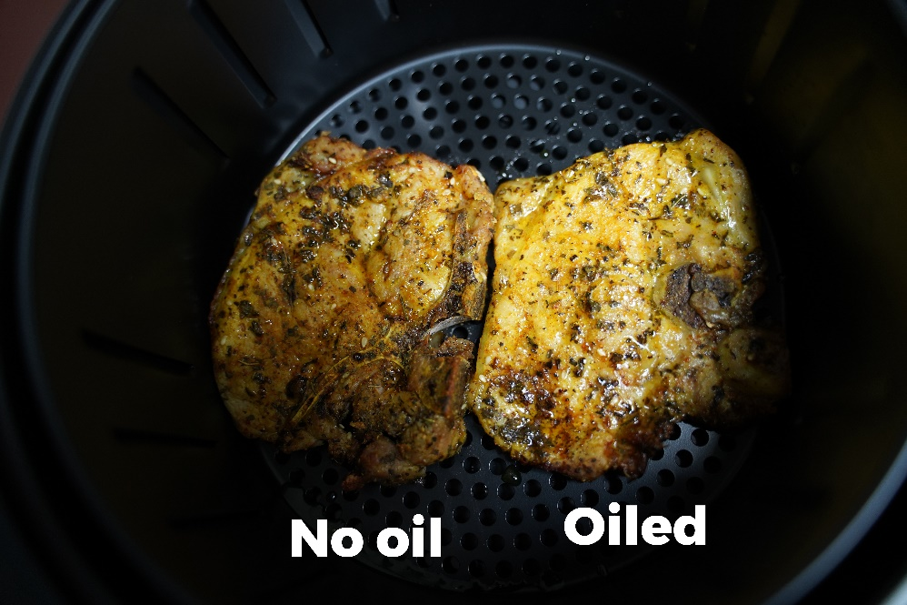
The chicken wings were also separated into two portions. One portion was coated with a teaspoon of cooking oil and other had no oil at all. The recommended Time on the air flight to cook chicken is 25-30 minutes at 180 degrees Celsius. We cooked the wings for 30 minutes at 180 degrees Celsius. 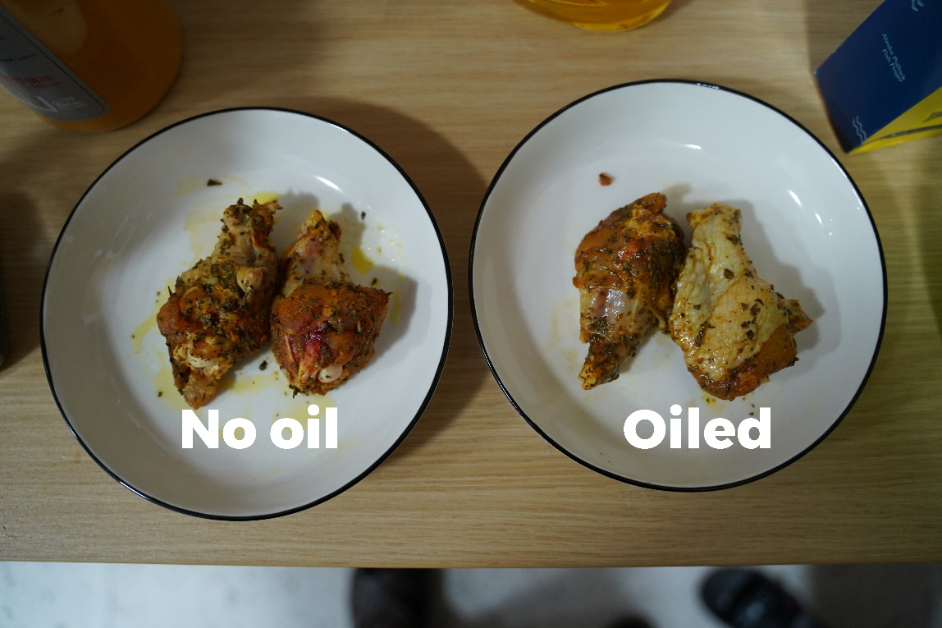
We added no extra oil to the fish fingers and cooked for 15 minutes at 180 degrees as recommended on the air fry. 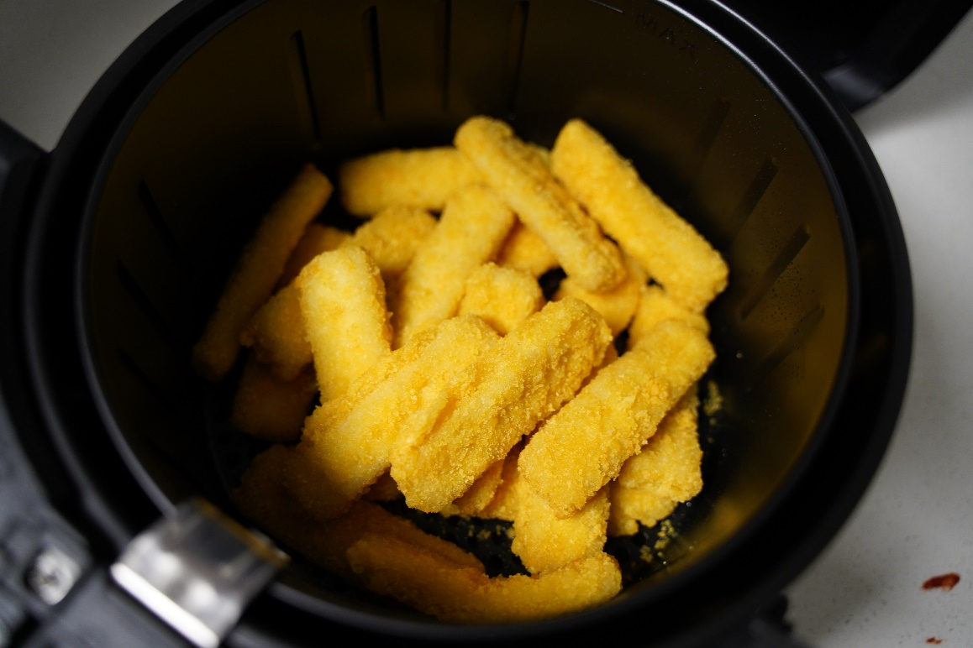
Lastly, we cooked the pre packed French fries for 20 minutes at 180 degrees although the fryer recommended cooking at 200 degrees Celsius.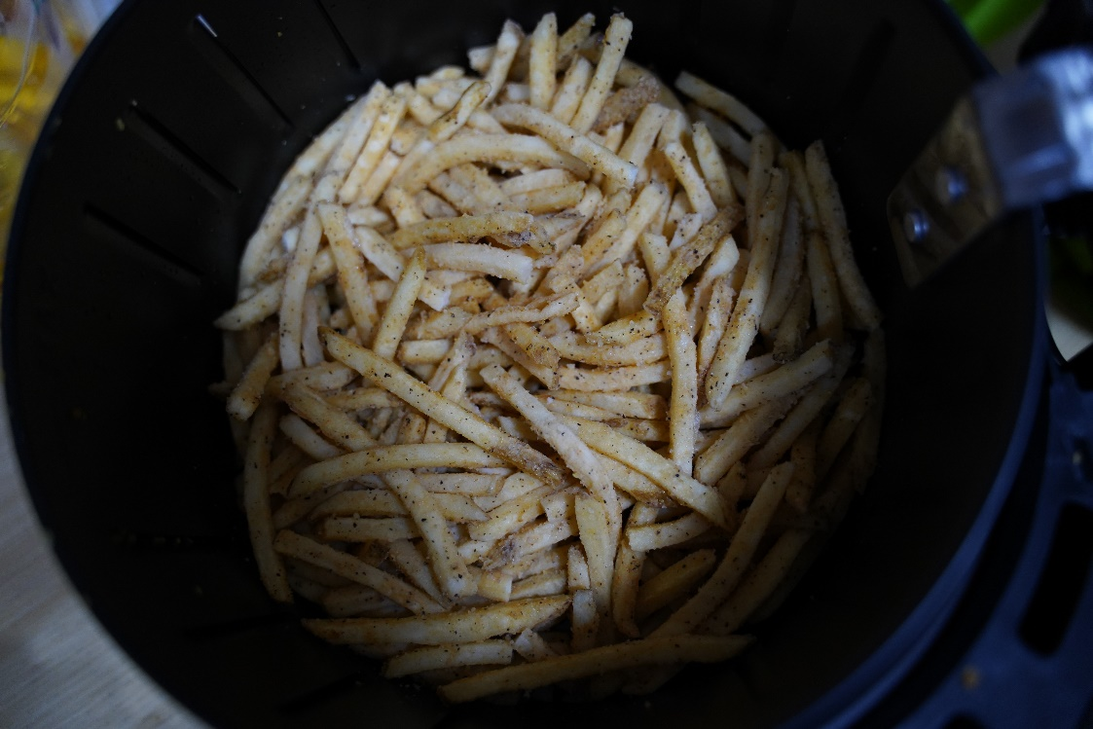
After using the air fryer, we let the basket cool then cleaned it with same materials mentioned earlier and allowed it to dry.
DETAILED RESULTS REPORT
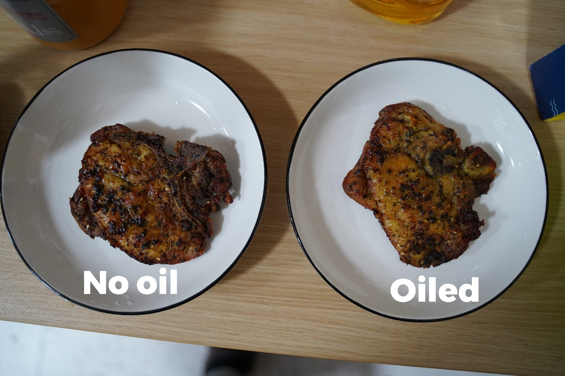
The pork was well fried and there was little to no difference between the oiled and non-oiled portions. The flavor and texture of both portions were similar.
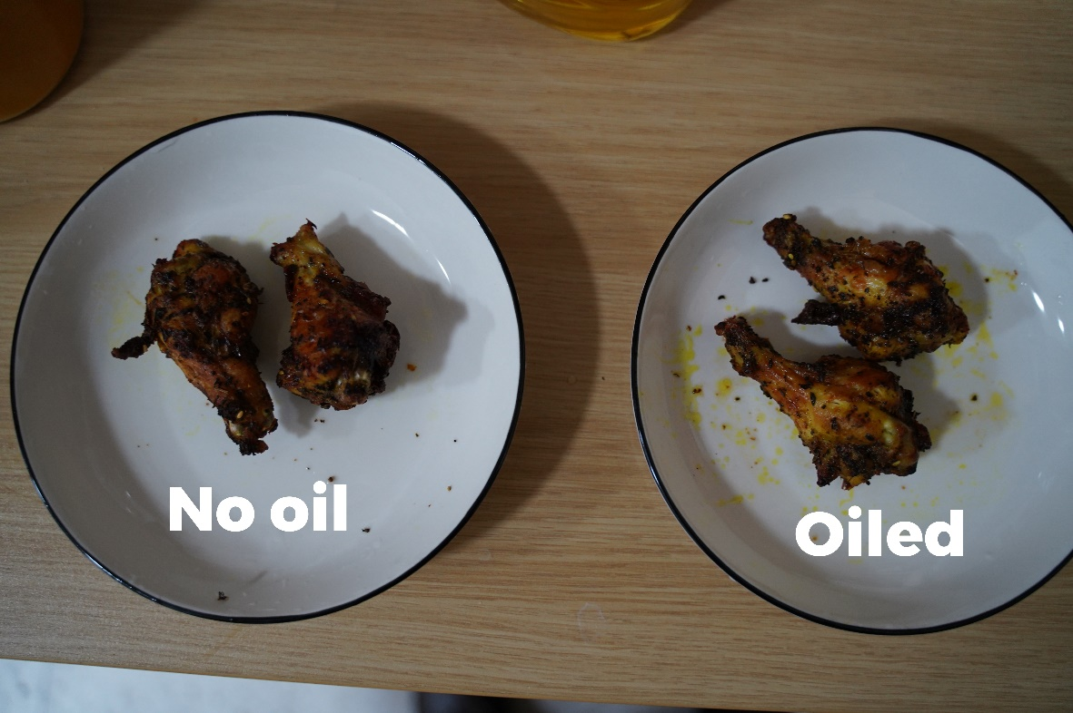
The chicken just like the pork steak was well friend and the pieces were indistinguishable from each other.
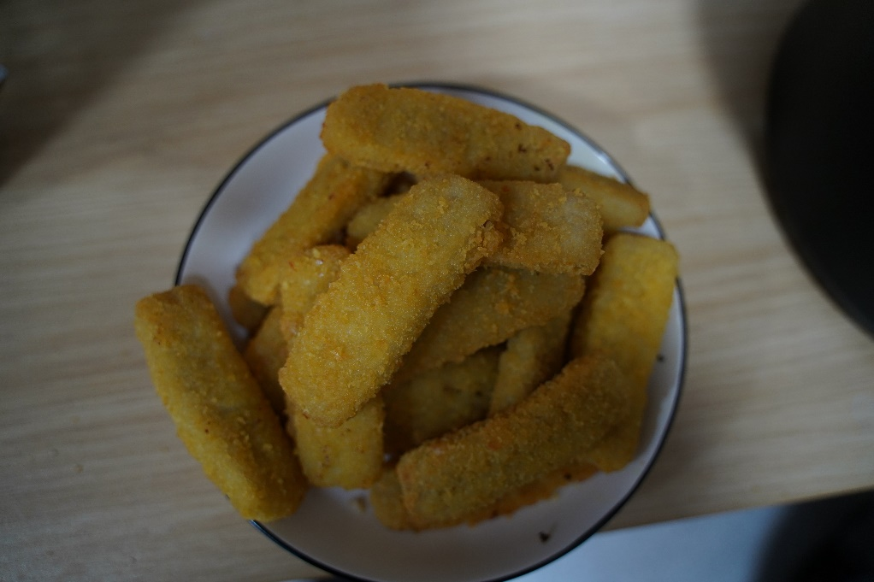
The fish fingers were thoroughly fried.

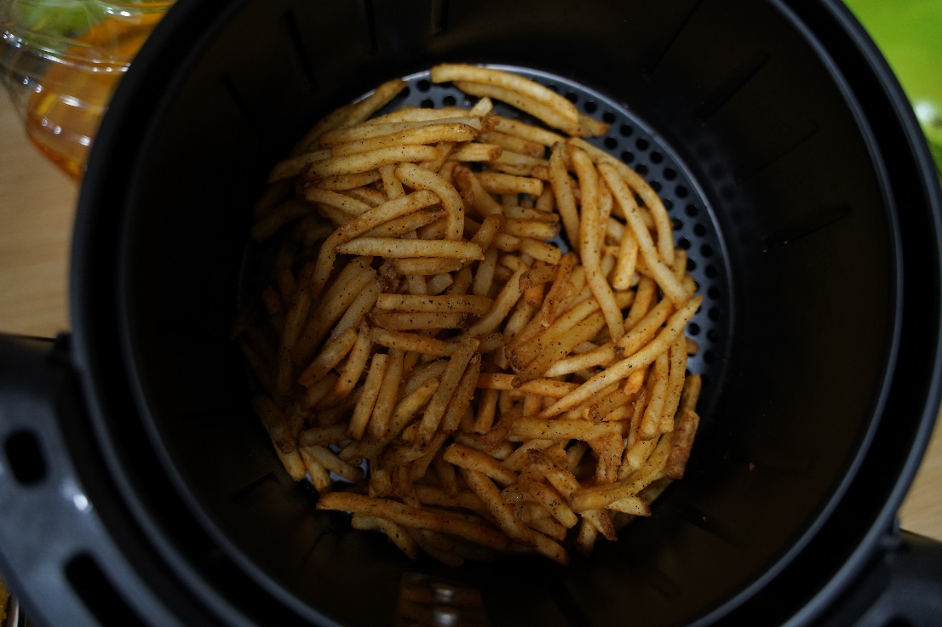
DETAILED EXPERIENCE REPORT (PROS & CONS)
We found the air fryer to be a convenient cooking appliance that made food preparation easier and faster. Some of its pros included:
- The food does not need constant monitoring unlike traditional frying as It allowed us to cook at a controlled heat for a specific amount of time, resulting in consistent and precise results.
- It was safer compared to traditional frying which tends to be a fire hazard and also cause a risk of burn injuries.
- It was not difficulty to figure out how to use it
- The basket was easy to clean and because it was detached prevented the risk of accidently soaking the electric systems
- Although we do not know the life of the appliance, we would be economic in the run because it eliminates the cost of cooking oil.
On the other hand, there were a few things we notice about this air fryer in specific such as;
- The zero error on the analog time nob.
- The occasional difficulty in fully closing the air fryer. The air fryer continued operation despite the basket not being fully closed.
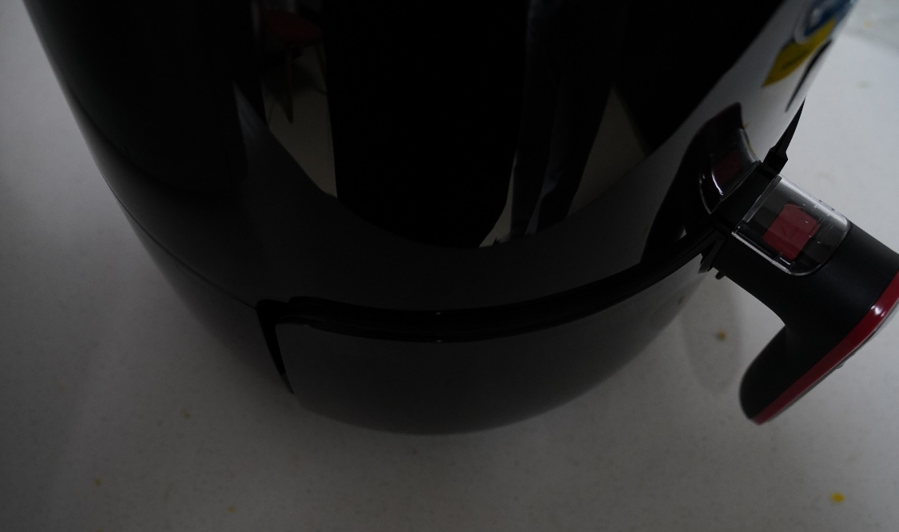
- The appliance was slightly heavier that it appeared.
- The material used was a bit slippery and the lack of handles to carry the fryer with made it a little difficult to carry
- The timer continued counting down even when frying was temporarily paused
VIEWS
We were impressed by the results because we did not think it was possible to get such results without the use of cooking oil. Usage of the appliance was quite simple and straightforward despite the lack of a user’s manual and requires no cooking skills. Cleaning was pretty straightforward and hustle free. Unlike traditional frying, no smoke or fumes are produced while cooking which is convenient for users who may be suffering from nasal or lung diseases.

